Compass MED D - Blue Medicare Rx (NEJE) Account Wellness Check List

Checklist
Tab View

Reminder: On every phone call, check each Account Wellness to ensure member will not have to make a return call. Document account with AWC.
- On third party calls (spouse, family member, friend), review the Account - Inform the caller if and when an issue is discovered to have the member contact customer care to discuss important information on their account.
Exceptions:
- Pharmacies, Prescribers, Medical Institutions, etc.
- Closed accounts (death of a member, no longer active)
- Plan has not yet started (beginning plan different month)
- Member hangs up before complete (notate the account)

Reminder: Adhere to HIPAA Guidelines at all times.

Checklist

Account Wellness Item | Item Check | ✓ | Why it is Important
Eligibility | Checked eligibility in Compass (Member Snapshot, Member Tab under Member Details)? |  | To ensure that we provide correct and accurate information.
Eligibility | Utilized all systems to verify eligibility (Fazal, and MARx)? |  | To ensure that we provide correct and accurate information.
Eligibility | Contacted the Senior Team for verification only if unable to locate in system? |  | To ensure that we provide correct and accurate information.
Verification | Verify the address on Compass (Member Snapshot, Member Tab under Member Details) |  | To ensure that contact information is up to date. It may eliminate issues with missed invoices, medications sent to the wrong address, not receiving order notifications in regard to their order and more.
Verification | Verify phone number on Compass (Member Snapshot, Member Tab under Member Details)
Verification | Verify email address on Compass (Member Snapshot, Member Tab under Member Details)
Verification | Ask for cell and email and proactively enroll in messaging alerts
Verification | View Past 12 Month Communication link for any Dunning notices and OOA mailings
Review Account | Viewing Member’s Recent Cases by accessing Case Details Landing Page, navigate to the Member’s Recent Cases panel and click View All. Click the appropriate Case hyperlink. From the Case Comments panel, click View All. |  | There may be instances that we have made outbound calls to try to get ahold of the member, there may be pertinent information to an order, has the member called and filed a grievance the same day? Is a Support Task asking for additional information or can we give the status on a Support Task to avoid a call back?
Review Account | Read Med D Alerts Tab comments
Review Account | Any mail order issues?
Order Placement  Auto Refill / Auto Renewal | Prescriptions available for refill? |  | To ensure that the member keeps up with their therapy without interruptions, they do not miss any refills that may be available or eliminate call backs to place an order that was available when they spoke to you.
Order Placement  Auto Refill / Auto Renewal | Any expired prescriptions?
Order Placement  Auto Refill / Auto Renewal | Any duplicate prescriptions?
Order Placement  Auto Refill / Auto Renewal | Prescriptions that have only one refill or have no refills remaining?
Order Placement  Auto Refill / Auto Renewal | Navigate to the Claims Landing Page, then click the Mail Order History tab. and check all open orders |  | Orders that are processing: confirm medication, strength, quantity, and form; confirm total cost of order (pricing disclaimer). If RTP’d, cancelled, on-hold correct issue so order will continue to process and ship
Transaction History / Maintain Payment Options | A mail order balance? |  | Educate the member of any balance that’s owed so that they can pay it on the same call if they wish, this can sometimes cause delays in the member’s mail orders. This will help to eliminate call backs.
Transaction History / Maintain Payment Options | Any orders that are on hold or delayed?
Premium Billing | A form of payment on file? |  | By ensuring to take payment when a balance is owed member can avoid disenrollment. If they owe a payment, member will not need to call back to make payment if you ask them if they would like to make a payment. Ask the member if they would like to enroll in automatic payments to avoid call backs.
Premium Billing | A form of auto payment on file?
Premium Billing | Has the beneficiary been recently educated on autopay?
Premium Billing | Has the beneficiary’s premium invoice been mailed?
Premium Billing | Past 12 months communication link for Dunning notices
Premium Billing | Review Med D Alerts Tab to see if member was mailed a Dunning notice
Premium Billing | Access Case Details Landing Page, navigate to the Member’s Recent Cases panel and click View All. Click the appropriate Case hyperlink. From the Case Comments panel, click View All for any outbound calls for Dunning.
Plan Benefit Override  View PA Status | Any Prior Authorizations that will soon expire? (in the next 60 days/two months) |  | PA’s allow for the member’s prescriptions to be filled by the plan, so it is important to educate the member of their expirations to ensure that there is no interruption in their therapy. It also minimizes the amount of times the member has to call. If an RX denies because of an expired PA the member will call back. Let’s take care of while the member is on the phone.
Plan Benefit Override  View PA Status | Prior Authorizations that have expired/have not been renewed?
Plan Benefit Override  View PA Status | Has the beneficiary been educated on their expiring PA(s)?
Account Balance | Met their deductible and/or drug spend (if applicable)? |  | Take the opportunity to educate the member on the phase of the plan they are in so that they better understand their costs. This is to avoid member calling back to learn why cost increased.  If in middle of phase, no need to mention.
Account Balance | Entered the coverage gap (if applicable)?*
View Opportunities (HEE)  Communication History  Caremark.com | Are there any opportunities to present to the member? Remember to disposition and save. |  | We can use this to check and make sure the member is receiving their communications appropriately, make sure they didn’t miss any alerts that need attention.
 | Ask for cell and email and proactively enroll in messaging alerts
 | Any recent letters and/or calls to member?
Educate member on the benefits of using Caremark.com
Offer to send a link to member to register for Caremark.com via email or text message
Coordination of Benefits | Does member have any other coverage? |  | By checking for other coverage, we could eliminate other calls, the member may have expired coverage still showing or need to add new coverage.

Top of the Document

Tab View

Remember to do your Account Wellness on each and every call – Performing Account Wellness is your opportunity to secure a First Call Resolution before ending the call. Account Wellness is a big part of ensuring our members are provided the best care possible.

- On the   verify address, phone number and email in both Participant Inquiry and Medicare D Inquiry Tab. Ask for cell and email and proactively enroll in messaging alerts. This is to ensure that contact information is up to date and may eliminate issues with missed invoices, medications sent to the wrong address, not receiving order notifications regarding their orders, and more. You can view comments and prescriptions.
- Access the Beneficiary’s account in Compass and click the Case tab. 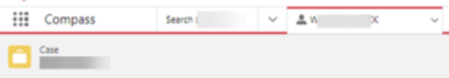 The Case Details Landing Page displays. Using the scroll bar between the two panels, scroll down to the Member’s Recent Support Tasks section and click the View All hyperlink. Call history displays past user’s notes and tasks that may have been created within a 90 day timeframe, date range can be adjusted.
- On the   view to check for available refills, refills remaining, ARR (auto refill/renewal). On the Participant Inquiry tab, check for Orders that are processing: confirm medication, strength, quantity, and form; confirm total cost of order (pricing disclaimer). If RTP’d, cancelled, on-hold correct issue so order will continue to process and ship.
- On the  and look to see if a member has any PA’s expiring in the next 60 days/two months, have any already expired and need to be renewed. If the tab is golden, then there is a PA that has expired or set to expire. You can also check status of PA’s and Appeals.
-  located under Quick Actions will show you what phase is the member in, what accumulators have been met or remaining in the phase to go to the next phase.
- While the MED D Customer Care Representative (CCR) has the capability to view correspondence with the beneficiary from the Communications hyperlink (located on Member Snapshot in the Quick Actions panel) 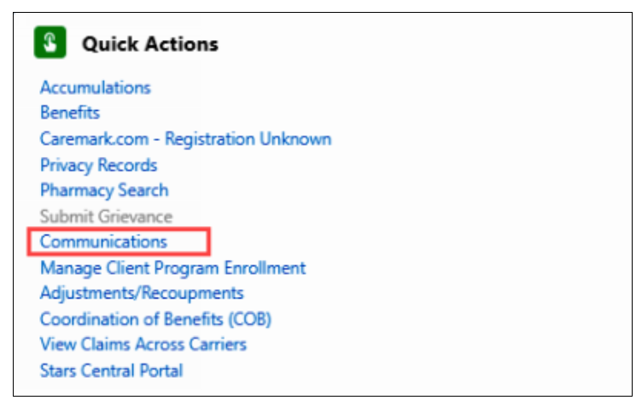, not all correspondence is loaded in this area. When the need arises to view an exact replica of the letter a beneficiary received, the CCR can also view the Last 12 Months of Communications (hyperlink) from the Medicare D Quick Actions panel 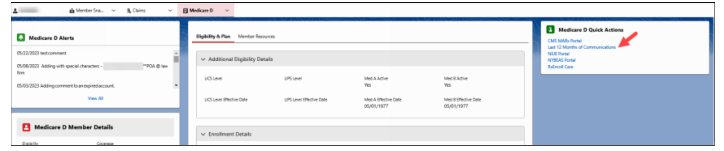.
-  under Quick Actions to see if the member has a secondary insurance.
-  give the member the plan offering such as meds available for ARP.
- On the  check  By ensuring to take payment when a balance is owed so the member can avoid disenrollment. If they owe a payment, member will not need to call back to make payment if you ask them if they would like to make a payment. Ask the member if they would like to enroll in automatic payments to avoid call backs.
- In Compass click the Case tab. The Case Details Landing Page displays. Using the scroll bar between the two panels, scroll down to the Member’s Recent Support Tasks section and click the View All hyperlink to see if there are any comments or information for the member accounts. (For example, Has the member called recently, order related issues, records of outbound calls made to member).
Top of the Document
Not to Be Reproduced or Disclosed to Others without Prior Written Approval
ELECTRONIC DATA = OFFICIAL VERSION / PAPER COPY = INFORMATIONAL ONLY

